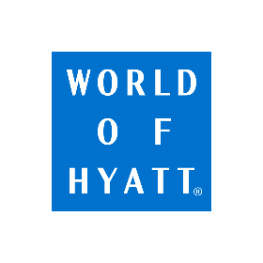**World of Hyatt Point Rewards Request Form:**

**HelmsBriscoe**

Submission Instructions: HelmsBriscoe Associate should complete all requested information in the fields below (please type all responses; do not hand-write) to receive World of Hyatt points. Send the completed form along with a copy of the fully executed contract to your hotel sales contact at the time the contract is signed. HelmsBriscoe must be listed as a third party in the contract and only the HelmsBriscoe Associate(s) listed below will receive the World of Hyatt points in connection with such contract.

|  |  |
| --- | --- |
| **Event Information** | |
| Property Name: | Total # Contracted Rooms: |
| Event Name: | Room Rate/F&B Commitment: |
| Event Start Date: | Event End Date: |
| Hotel Sales Contact: | Contract Signature Date: |
| Comments: | |

|  |  |  |  |  |
| --- | --- | --- | --- | --- |
| **HelmsBriscoe Associate Information** | | | | |
| **FIRST NAME** | **LAST NAME** | **WORLD OF HYATT ACCOUNT NUMBER** | **EMAIL ADDRESS** | **PHONE NUMBER** |
|  |  |  |  |  |
|  |  |  |  |  |
|  |  |  |  |  |

Keep in Mind:

* Events with at least ten (10) rooms per night on peak must be booked within the group block in order to qualify.
* There is a maximum of 50,000 World of Hyatt bonus points per contract, unless otherwise negotiated by the Hotel.
  + World of Hyatt points will be credited by the Hotel at completion of event.
* This form must be submitted with a copy of the fully executed contract no later than thirty (30) days after the contract’s signature date in order to qualify. If for any reason this form is not submitted with the appropriate documentation or within the time allotted, World of Hyatt points may not be awarded.
* Point awarding is subject to the property’s process and approval, which may include additional terms, requirements, or restrictions.

All points and rewards are subject to WOH program terms, including expiration <https://help.hyatt.com/en/hyatt-terms/world-of-hyatt-terms.html>.

Hyatt Corporation reserves the right to alter or withdraw this offer at any time for any reason, with or without notice.

By:

Name:

Title:

Hotel Name: